EECS 358 Assignment 2

Honghao Xu, Lunrong Chen

Problem 1

1. Steps:
   1. Applying ring algorithm on the row 2, taking $log6=3$ steps. In details, at the first step, the message is sent to (2,5); at the second step, the message is sent to (2,6), (2,3); at the third step, the message is sent to (2,1), (2,4)
   2. Applying ring algorithm on every processor columns, taking $log6=3$ steps. In details, at the first step, the message is sent to (5,i) (i stands for column); at the second step, the message is sent to (6, i), (3, i); at the third step, the message is sent to (1,i), (4,i).

Total: $6$ steps

Time: $2\left(10+0.01*1000\right)*3+2*2\left(6-1\right)=140 ms$

1. Steps:
   1. Applying ring algorithm on each row, taking 5 steps. In the first step, every processor consolidates all the data to be sent and sends a message to the next processor on its row. In every subsequent step, processors retain part of the message received for themselves and send the rest to the next processor on its row.
   2. Applying ring algorithm on each column, taking 5 steps. In the first step, every processor consolidates all the data to be sent and sends a message to the next processor on its column. In every subsequent step, processors retain part of the message received for themselves and send the rest to the next processor on its column.

Total: 10 steps

Time: $2*\left(10+0.5*36*1000*0.01+2\right)\left(6-1\right)=1920 ms$

1. Steps:
   1. For processors from the column 2 to column 6, the message of processor (i, j) is sent to (i%6+1, j).
   2. For each row, the message of processor (i,j) is sent to (i, j%6+4).

Total: 2 steps

Time: $\left(10+1000*0.01+2\right)+\left(10+1000*0.01+2\right)*2= 66 ms$

Problem 2

Machine count: 1

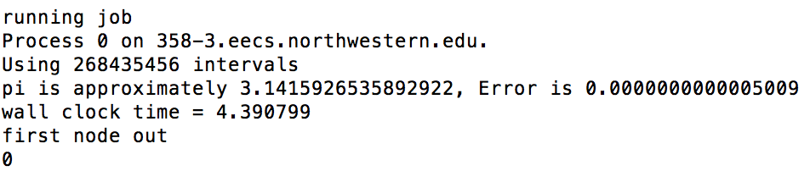

Runtime: 4.390799s

Machine count: 2

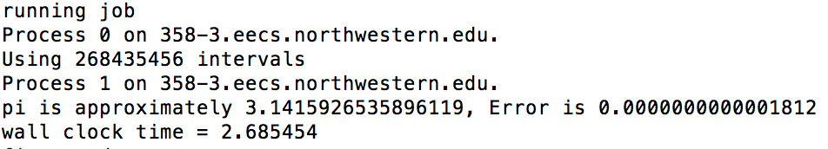

Runtime: 2.685454s

Machine count: 4

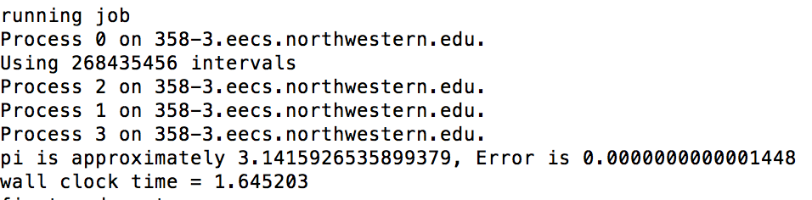

Runtime: 1.645203s

Machine count: 8

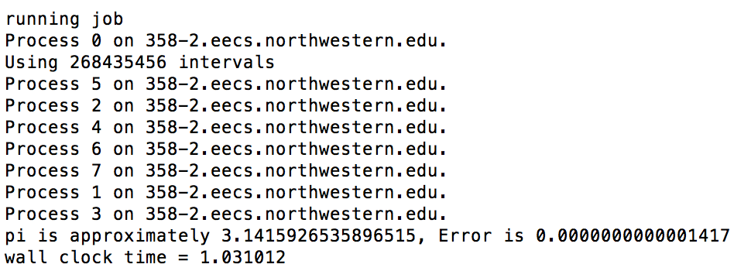

Runtime: 1.031012s

Machine count: 16 (Gathered from launcher)

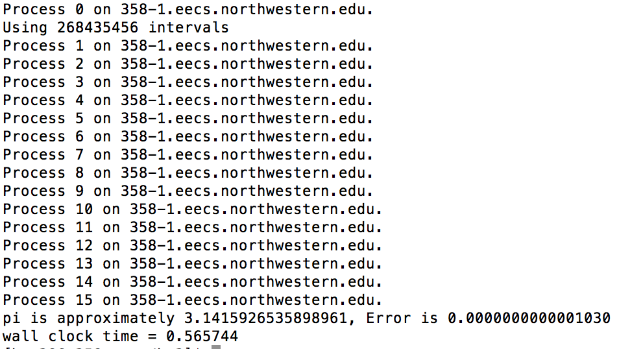

Runtime: 0.565744s

Problem 3 (Gathered from launcher)  
Result:

1 Processor: 2 Processors:

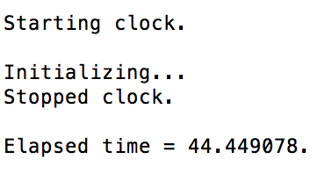 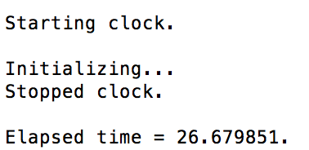

Runtime: 44.45s Runtime: 26.68s

4 Processors: 8 Processors:

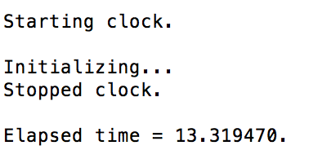 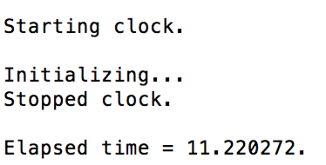

Runtime: 13.32s Runtime: 11.22s

16 Processors:

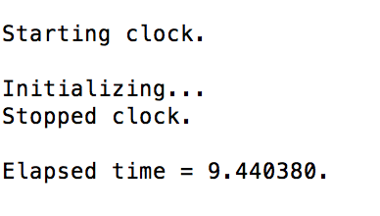

Runtime: 9.44s